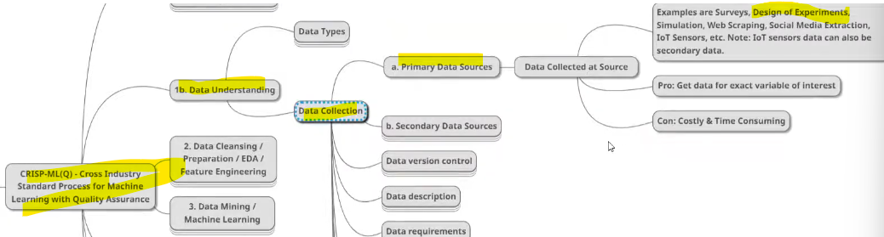

In below data are collected by doing new experiments on the market, example in below we provide 20% discount on non-veg at week end days with the discount limit of two days, by doing this we can know that is the customer orders are increased, and the orders are will be stored as data, we will do analysis on such data. So this is who data collected using design experiments.

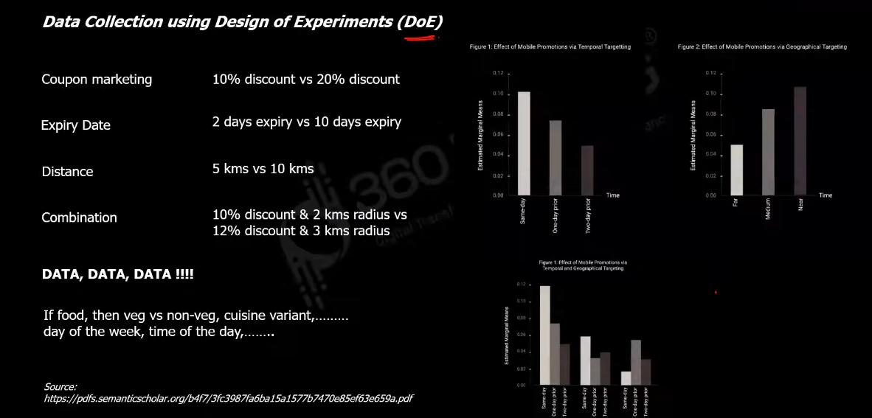

**ERRORS DURING THIS DATA COLLECTION**

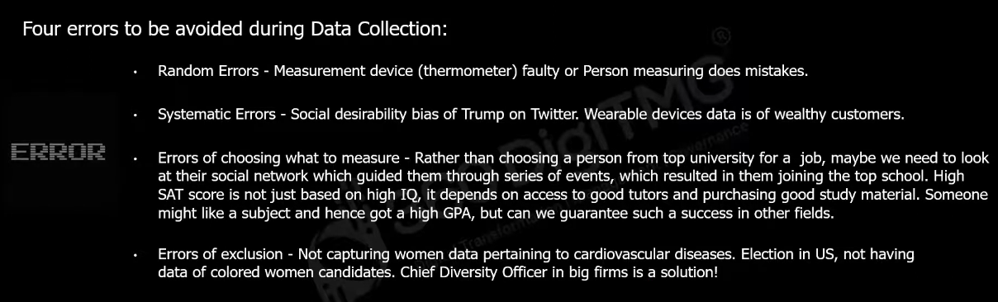

We don’t be bias for choosing data, otherwise the below problem will occur

